|  |
| --- |
|  |
| Void Demon |
|  |
|  |
| **Kaitlyn Moeller** |
|  |

Table of Contents

Premise/High Concept 2

Features 2

Player Motivation 2

Gameplay Highlights 3

Technology Highlights 3

Backstory and Game World 3

Gameplay and Mechanics 4

Mission and Story Progression 6

Character Descriptions 7

Alex Foxwell 7

Inanis 7

Sarah Foxwell 8

Edward Foxwell 8

Father David 8

Mary 8

User Interface 9

Platform 10

Project Management 11

Team 11

Budget 12

Schedule 12

# Premise/High Concept

Void Demon is a third-person survival horror game with various 2D point-and-click elements and combat styles. You must gather devastating information, magical objects, and character support to defeat the vile, manipulative demon.

# Features

* Multiple defensive actions known as “resist”
  + Action set that helps the player resist the demon’s control
    - Brief sections of dialogue options, button mashes, and joystick/mouse slides are randomly chosen
  + The player can “resist” only if the demon challenges the player
* Multilayered point-and-click elements
  + Sometimes, multiple drawers and computer files must be clicked through to obtain important objects and information
* Players can hide behind, inside, and underneath certain fixed objects
* During the final boss, the NPC priest and his daughter will assist the player in battle
  + Be careful because they might die

# Player Motivation

Properly killing or capturing the demon via magical objects is the game’s main victory condition. Several factors contribute to the player’s motivation. The most important factor is emotional storytelling. Environmental and social character interactions are essential. A blend of competition and cooperation is vital. Foes can be aggressive, sneaky, obvious, and/or traitorous. Helpful characters provide tips, medicines, and upgrades. Point-and-click exploration and codes will test the player’s cognitive skills.

# Gameplay Highlights

Most importantly, the player must gather pertinent information and objects. These all connect to short-term and long-term goals. Exploration and puzzle solving are essential to gameplay progression. Keys unlock certain files and locations. Sometimes, the player must hide from creatures. NPCs and notes provide tips about the final boss. The player must determine who to believe. Based on the adversary’s weaknesses, aggression or stealth must be used. Lore notes and files supplement the player’s experience.

# Technology Highlights

The GameMaker Studio 2 engine will be utilized. Many of its features emphasize 2D art. Layers make it easy to distinguish between the game’s environment, objects, and characters. Brush based editing allows developers to create game art within the software. Animation support combines similar game art to form animation. Sound mixer organizes ambience, music, sound effects, and dialogue.

# Backstory and Game World

Before the game’s events, Alex is portrayed as smart and friendly. During his childhood, he experienced mental torment. His moderate schizophrenia interfered with daily life. This condition led to fluctuating degrees of anxiety, depression, and paranoia. Occasionally, Alex suffered from intense sleep paralysis. When he was thirteen years old, his distress temporarily ceased. Regardless of his misery, Alex strived to help others. Sometimes, he played video games and watched horror movies. Other times, Alex and his parents would hang out. Alex’s parents often celebrated their son’s improved mental health. Nevertheless, this did not remain the case.

On June 24, 2011, Alex is seen packing his bags inside his parents’ New Jersey home. This modest, suburban home is a recurrent location. A few minutes into the game, Alex drives his newly bought red car. Sunny, clear blue skies, and forest greenery surrounds him. Eventually, Alex crashes into a telephone pole. Moments later, he opens his eyes inside a well-sterilized medical hospital. Soon after his escape, Alex ran back to his parents’ home. A couple hours later, Alex returns to a bleaker version of the home. Now, his room closely resembles solitary confinement. Weeks later, he is sent to Moonlight Vale. Upon arrival, he notices the asylum’s barbaric, unsanitary, and gloomy appearance. During Alex’s stay, he encounters a variety of characters. Some are oddly cheerful. Others are ruthless and sadistic. Months later, he escapes to his parents’ still bleak home. Both parents succumbed to panic. They wanted to help. However, they were unsure of what to do. Eventually, they decided to call the local church. A priest and his daughter from a rustic, humble church arrive inside the home. Each location contains grotesque handwritten and/or digital notes. Near the end, Inanis shrouds the parents’ home in blood red. Once the conflict is resolved, the home is returned to normal.

# Gameplay and Mechanics

Primarily, the game will be played by exploration and point-and-click mechanics. Solvable codes and puzzles are commonplace. All pre-boss levels require the player to run, hide, and/or defend themselves against Inanis. The player must hide from powerful foes. A knife can be used to slay weaker enemies. Occasionally, the player must interact with NPCs.

The medical hospital appears ordinary and peaceful. However, a few disturbing elements are hidden. Alex’s bedroom is gloomy and bland. Nevertheless, a secret door reveals a much different scenery. Once the player enters the hidden room, the atmosphere becomes repulsive. Moonlight Vale is a large, unsanitary asylum. Various characters appear on screen. Their personalities range from cheerful to deranged. Usually, appearance indicates personality. Sometimes this is not the case. Enemies must be slain. Meanwhile, allies must be spoken to and helped.

Many game world and character interactions are possible. The player can pick up highlighted items, unlock doors, open files, and examine notes. Stationary objects can be used as hiding spots. Demon visits become more frequent as progress is made. Before the final boss, the player can temporarily hide and defend himself/herself from the demon. At the game’s end, Inanis can be killed or captured. There are two ally types. Immediately upon encounter, allies may assist the player. Others may force the player to complete a favor. If enemies kill the player, then he/she will spawn back at beginning of the room/section. The player keeps his/her inventory. Respawns are infinite unless the player is at the final boss.

If permanent Inanis capture or death occurs, then the player wins and Inanis loses. After too many deaths, the player loses and Inanis wins. If temporary Inanis capture or death occurs, then no one wins or loses.

# Mission and Story Progression

Alex Foxwell is the story’s protagonist. He packs his bags, says his farewells, then drives away from home. While on the road, he is interrupted by an ominous voice. Alex believes this is simply a bizarre thought. “Swerve!” and other temptations were uttered by a manipulative demon. Uncharacteristically, Alex gave into the urge. He quickly crashed into a telephone pole. Miraculously, he survived. However, Alex was unconscious with severe injuries. An unidentified man picked Alex up then drove him to a nearby hospital. Days later, he slowly awakens from his bed. Physically, he felt ready to escape. Nevertheless, his mind did not agree. He escaped then ran back home to inform his parents.

Alex told his parents, Sarah and Edward, everything he could. Edward suggested it was “call of the void.” He explained the phenomenon to Alex then told him to resist it. While Alex drove, the voice physically manifested as a shadow entity. It grabbed the wheel, forcing Alex to swerve into a building. The entity quickly vanished. Surprisingly, Alex did not get severely injured. Nevertheless, he looked down then bawled his eyes out. Eventually, he returns to his parents. When he reported this story, Mr. and Mrs. Foxwell grew significantly worried. After some bickering, Sarah requested psychiatric services over the telephone. His parents locked him into an emptier version of his room. Alex manages to escape but notices strange people. They grab Alex by his arms then force him into the vehicle’s backseat.

Unknowingly to Alex’s parents, he is sent to the notorious insane asylum, Moonlight Vale. Alex slowly opened his eyes then looked around his cell. It is a small enclosure with a tattered bed and notes. Seconds later, Inanis the demon physically manifested and corrupted the room. Alex realized that it was the source of his declining sanity. Consequently, his fear turns into rage. During his stay, Alex encounters a variety of characters. Through lots of exploration and puzzles, he managed to escape.

Weeks later, Alex knocks on his parents’ door. Both his parents are surprised to see him again. However, they notice that he looks battered. Mr. and Mrs. Foxwell contact a priest of a local, humble church. Father David and Mary, his daughter, enter their home. All five characters discuss the matter. Eventually, Alex’s parents are temporarily forced out of their home. David and Mary help Alex defeat Inanis.

The player influences the game’s ending. If the player successfully captures or kills Inanis, he/she receives the “serenity” ending. This is the best outcome. When the player improperly captures or kills the demon, then it sneakily escapes. In this ending, both characters survive. This results in the “false security” message. If the player dies too often and Inanis survives, then the player receives the “consume” ending.

# Character Descriptions

## Alex Foxwell

He is an 18-year-old high school graduate protagonist. The young man has brown hair, and blue eyes. Usually, his clothes are black and blue. His bedroom suggests that his interests are gaming and horror. Although his past made him suffer, Alex is academically gifted and friendly. He is directly tormented by Inanis.

## Inanis

Inanis is the void demon antagonist. The entity manifests as a pure black shadow. Occasionally, two white eyes are revealed. Gradually, the entity torments Alex and interferes with his life. Each of its hauntings are worse than the last. It begins with subtly manipulative tactics. However, it becomes more gruesome and violent.

## Sarah Foxwell

Sarah gives Alex emotional support. The middle-aged woman has dirty blond hair and blue eyes. She wears casual clothes. Depending on the player’s dialogue choices, she might be the calm or frantic parent. The player influences the amount of her logical and emotional statements.

## Edward Foxwell

Edward acts like Alex’s mother. He also provides Alex with emotional support. The middle-aged man has brown hair and eyes. He wears blue-collar worker’s attire. Depending on the player’s dialogue choices, he might be the calm or frantic parent. The player influences the amount of his logical and emotional statements.

## Father David

Father David is the local church’s well-respected priest. The young man has brown hair and blue eyes. He wears a black roman cassock. David is a humble man. The father is Mary’s religious mentor. His goal is to banish Inanis from existence.

## Mary

Mary is David’s only daughter. The teenager has blonde hair and blue eyes. She wears the same type of clothes as her father. Mary is kind but opinionated. She does not always follow David’s instructions. Her goal is to assist her father.

# User Interface

PC users play the game with a keyboard and mouse. Standard WASD keys allow the player to move. Players must double tap W, A, and D keys to run. However, the S key has no use because the player is not allowed to manually walk along the z-axis. The E key is used to grab and use items. Q to pull up the detailed inventory. Most players can quickly access E and Q buttons. Nevertheless, this is not always the case. Therefore, keys can be reassigned. Mouse scrolls and number keys switch between inventory slots. Point-and-click is dictated by the left mouse button. The ESC key is used to access the in-game menu. Console controls slightly differ. This is established in the document’s platform section.

Manually, players can walk, run, and hide. Players can pull up the in-game menu and detailed inventory. Visually, players can attack and defend themselves. Players can pick up objects and choose dialogue options.

Passive elements include player health, five inventory slots, and the journal icon. Active elements include detailed inventory, journal, and in-game menu systems. The journal contains objective information and notes. In-game menu buttons are resume, save, and title screen options. Title screen buttons are new game, continue, and options. Audio, visual, and key reassignments are in the options menu.

Gameplay is made accessible via mostly standard controls. Most players have their hand near the WASD keys. This allows easy player movement. Q and E are close to WASD. Key reassignment allows players to modify controls to individual needs and wants.

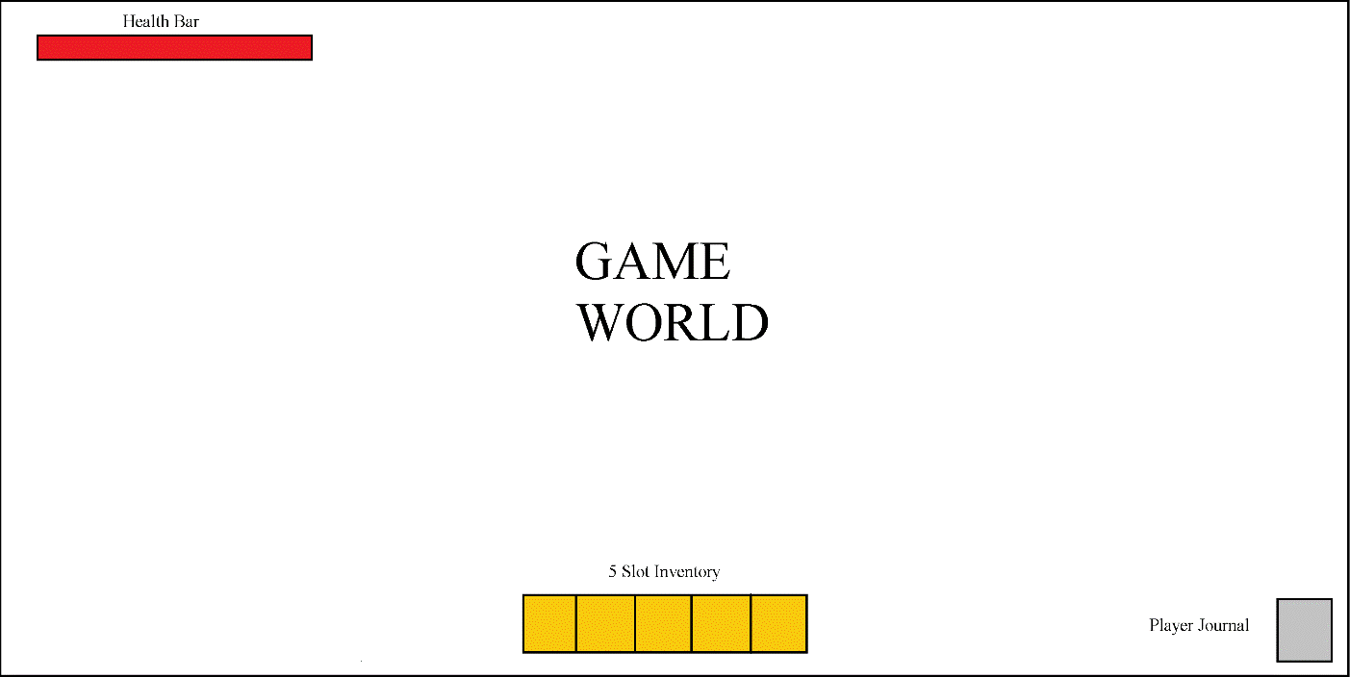

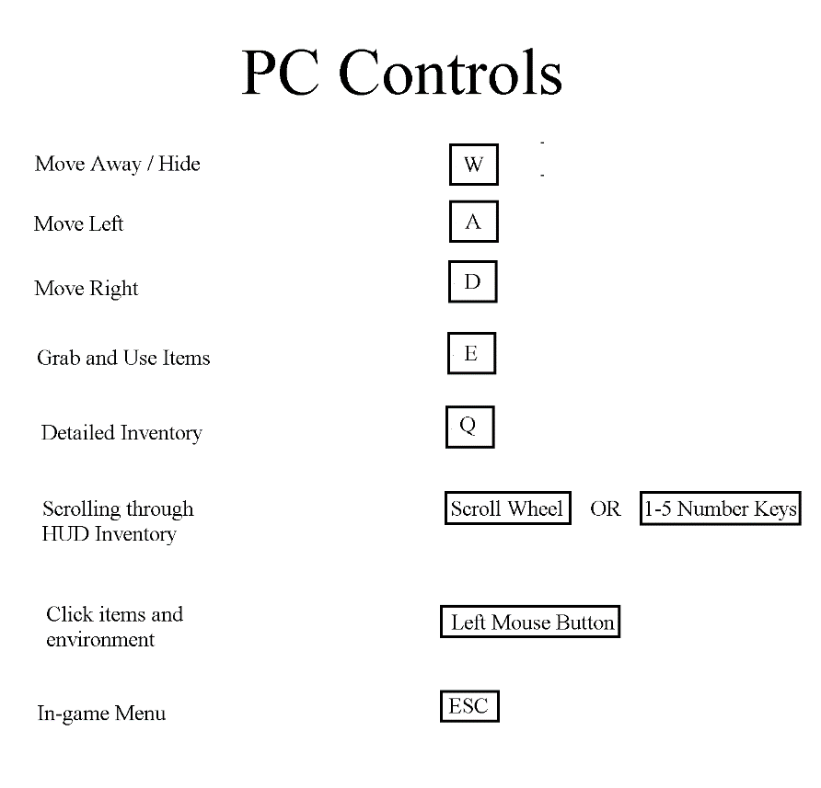

# Platform

PC is the primary targeted platform. Windows, Mac, and Linux are in this category. There are numerous timed and precision elements. Keyboard and mouse controls provide more accuracy than console does. PC is more flexible and customizable. Secondary platforms include Xbox and PlayStation. Instead of WASD keys, players move the left joystick. The right button is to grab and use items. Players cannot use clicking mechanics. Rather, they must stand near objects and locked zones. Players press the left button to examine the area. The top button accesses the detailed inventory. Right joystick is used to scroll through the inventory. The bottom button accesses the in-game menu. Both platform types use various physical inputs to let the player feel like he/she controls the character.

# Project Management

## Team

1. Designer and Artist
   1. Kaitlyn Moeller
2. Programmer and Writer
   1. Generic Member
3. Sound Engineers
   1. Midnight Syndicate (two people)
   2. Jacob Lizoette

## Budget

|  |  |  |
| --- | --- | --- |
| Team Member | Budget | Notes (if any) |
| Kaitlyn Moeller | $41,680/year * 2 years development time = $83,360 total | This is calculated by the approximate entry-level game designer salary in Arizona. |
| Generic Member | $53,463/year * 2 years development time = $106,926 total | This is calculated the approximate entry-level game programmer salary in Arizona. |
| Midnight Syndicate  (two people) | $45,210/year * 2 years development time = $90,420 total  $45,210/year * 2 years development time = $90,420 total | This is calculated by the approximate entry-level sound engineer salary in Ohio. Since there are two members, the salary is listed twice. |
| Jacob Lizotte | $40,219 /year * 2 years development time = $80,438 total | This is calculated by the approximate entry-level sound engineer salary in Maine. |

## Schedule

|  |  |  |
| --- | --- | --- |
| Milestone # | Timeframe | Deliverables |
| 001  (Year 1) | January 1st – March 1st | Concept and pre-production complete |
| 002  (Year 1) | March 1st – June 1st | Complete implementation of objects, characters, and backgrounds |
| 003  (Year 1) | June 1st – September 1st | Complete programming/scripting of animations, physics, logic, progression, and math |
| 004  (Year 1) | September 1st – December 1st | Complete implementation of ambience, music, and sound effects |
| 005  (Year 2) | January 1st – March 1st | Released alpha version, gather user feedback, and discuss how to move forward with game development |
| 006  (Year 2) | March 1st – June 1st | Tune gameplay, fix logic errors, and remove programming bugs |
| 007  (Year 2) | June 1st – September 1st | Released beta version, gather user feedback, and prepare game for gold master release |
| 008  (Year 2) | September 1st – December 1st | Released highly polished gold master version |